****

**BIG DATA ANALYTICS LAB**

**WEEK-6**

**NAME : BRANCH & SEC :** CSD-B

**ROLLNO :**   **DATE : 06**-11-24

**PROBLEM STATEMENT:**

1. **Run Pig and perform basic PIG commands**
2. **Write PIG latin Scripts to sort , group ,join,project and filter your data.**

**Source code:**

**OPENING PIG:**

**pig -x local**

**LOAD and DUMP:**

**week 6 1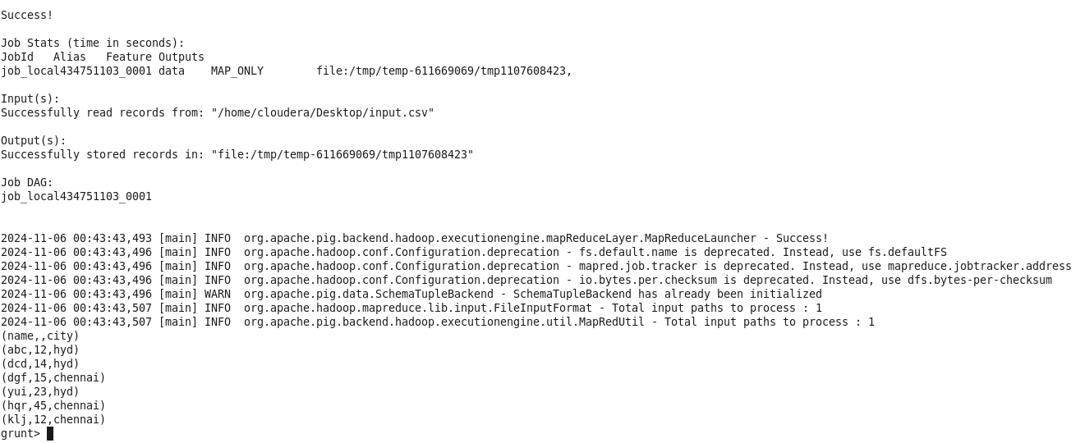**

**week 6 15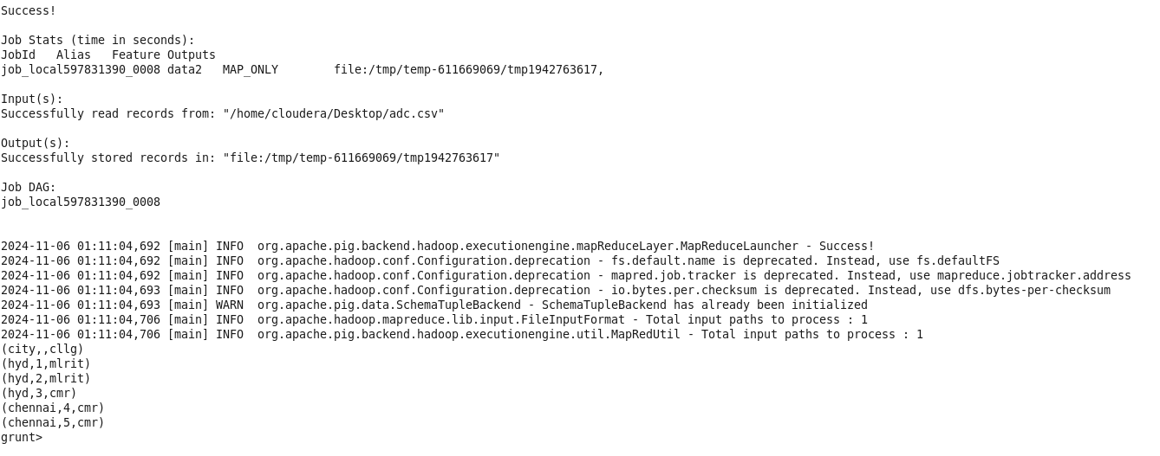**

**FILTER:**

**week 6 3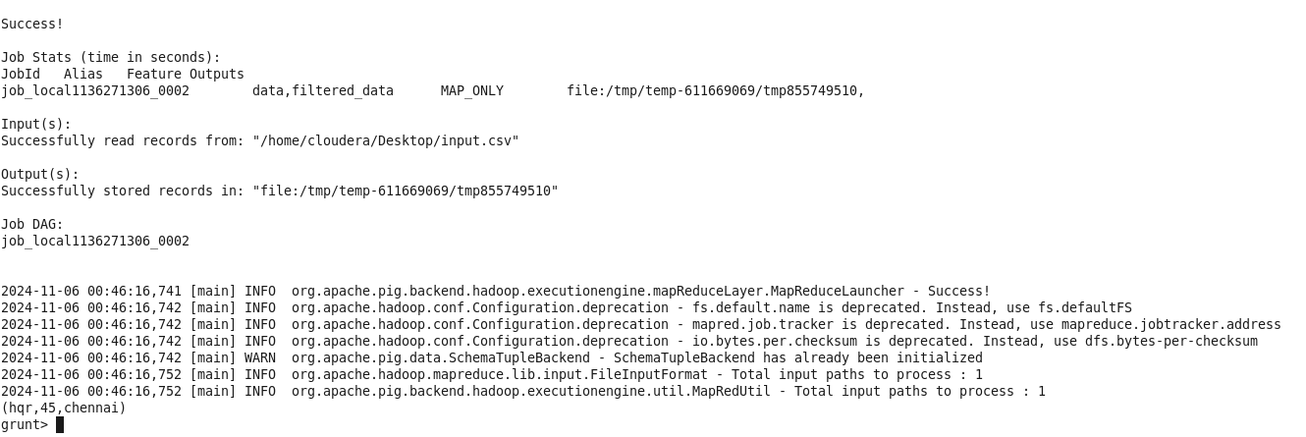**

**GROUP:**

**week 6 5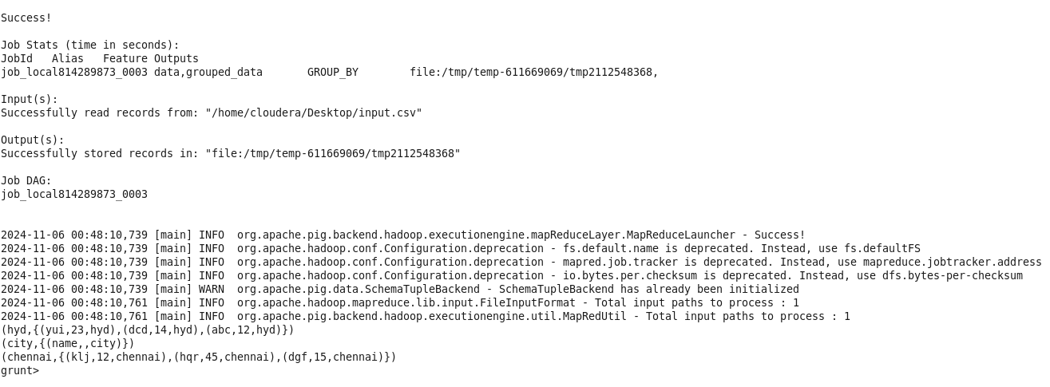**

**AGRREGATE DATA:**

**week 6 7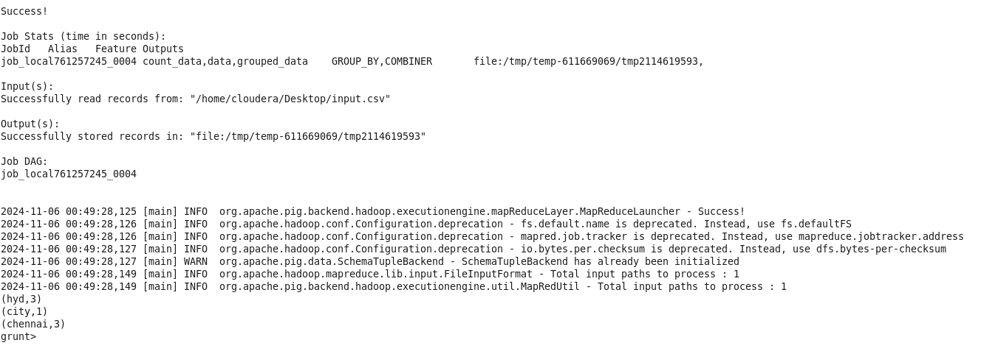**

IMG_256

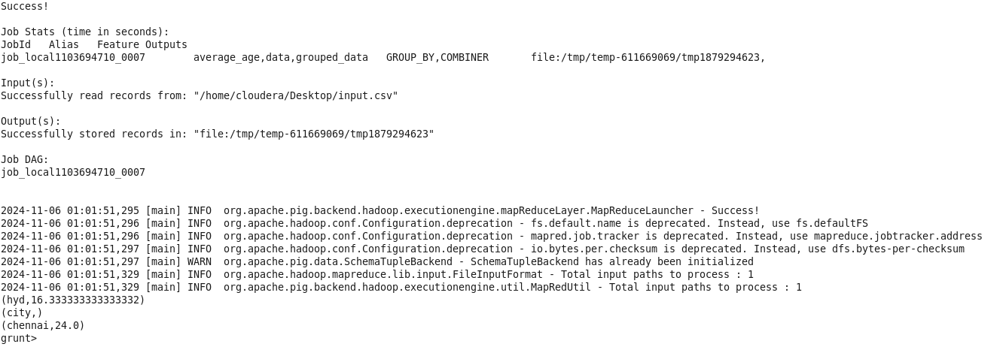

**STORE:**

**week 6 9**

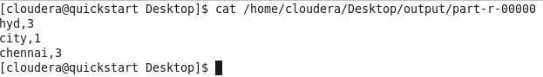

**DISTINCT:**

**week 6 11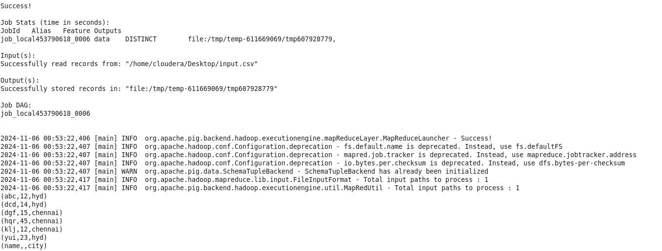**

**JOIN:**

**week 6 17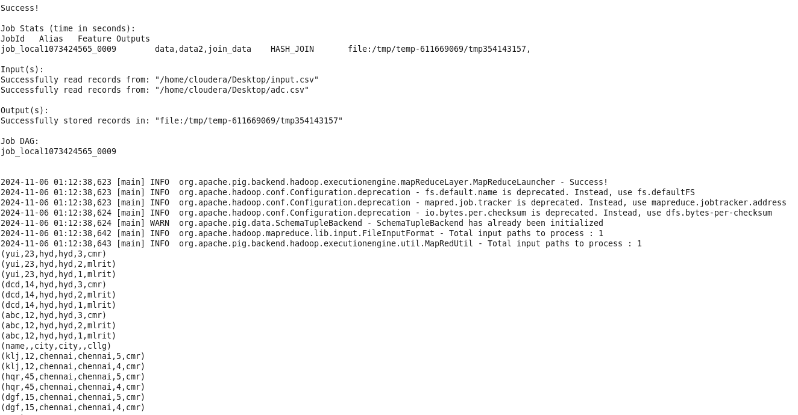**

**SORT :**

**week 6 19